**Name: merin joseph**

**Roll No:20**

**Batch:b**

**Date:25-4-2022**

**NETWORKING & SYSTEM ADMINISTRATION LAB**

**Experiment No.: 8**

**Aim**

familirization of linux commands

**Procedure**

**1.useradd.**

*useradd is a command in Linux that is used to add user accounts to your system.*

**Output Screenshot**



**2.password**

passwd command in Linux is used to change the user account passwords.

**Output**

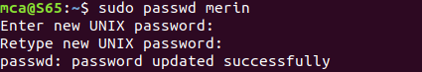

**3.groupadd**

*groupadd* command is used to create a new user group.

**Output**



**4.usermod**

usermod command or modify user is a command in Linux that is used to change the properties of a user in Linux through the command line.

**Output**



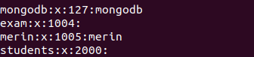

**5.compgen**

compgen is a bash built-in command which is used to list all the commands that could be executed in the Linux system.

**Output**

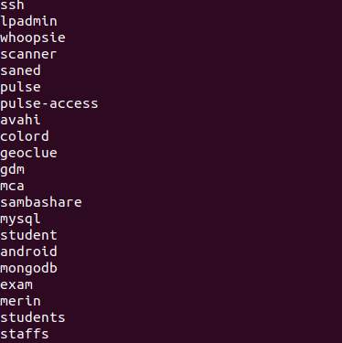

**6.userdel**

userdel command in Linux system is used to delete a user account and related files.

**Output**

**7.groupdel**

groupdel command is used to delete a existing group. It will delete all entry that refers to the group, modifies the system account files, and it is handled by superuser or root user.

***Output***



***8.chmod***

*In Unix-like operating systems, the chmod command is used to change the access mode of a file.  
The name is an abbreviation of change mode.*

***Output***

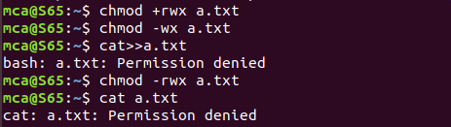

***9.chown***

*chown command is used to change the file Owner or group. Whenever you want to change ownership you can use chown command.*

***Output***

